Site Purpose: Provide a brief statement about the purpose of the website drawing upon the client's functional specifications, the industry, and any fictitious but viable goals that you deem to be reasonable.
El propósito de mi website será el de vender habitaciones de hotel. Los futuros clientes/interesados podrán ver las habitaciones con las que cuenta el hotel y podrán saber las especificaciones de ella. También, podrán ver como esta el clima en cada locación que tenemos. Además, podrán enviar su información para reservar el cuarto deseado.

Target Audience: Research who the website visitors will be by discovering the industry, visiting similar sites and asking your friends, family or acquaintances through an informal survey about the industry. You may elect to develop personas Links to an external site.for the distinct type of site visitors. This section should describe the target audience being judicious about the selection of the most plausible demographics.

Mi target audience serán familias de 2 a 8 miembros, esto incluye pero no se limita a bebés, niños pequeños, jóvenes, adultos y ancianos. Principalmente el sitio lo verán adultos de todo el mundo por lo que deseo que sea atractivo para ellos y que cuente con todos los servicios tanto para parejas como parejas con hijos.
Site Map: The site map is a sketch of all the website pages and references. It should illustrate the relationship between those pages.
Lo principal sera el Home Page, en el menú bar se encontrarán las sub paginas como Rooms, Services, Page, and Reservation.
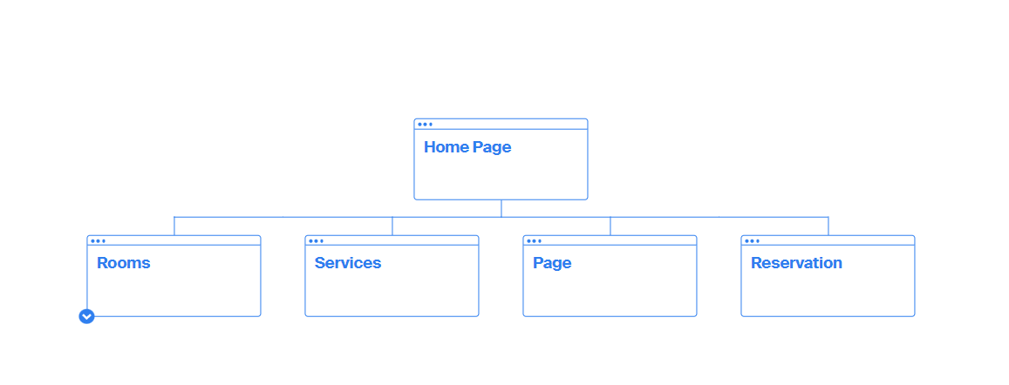
Color Scheme:
Since my website is for the purpose of selling hotel rooms, I will choose neutral, solid, and clean tones. My palette is in the image below.
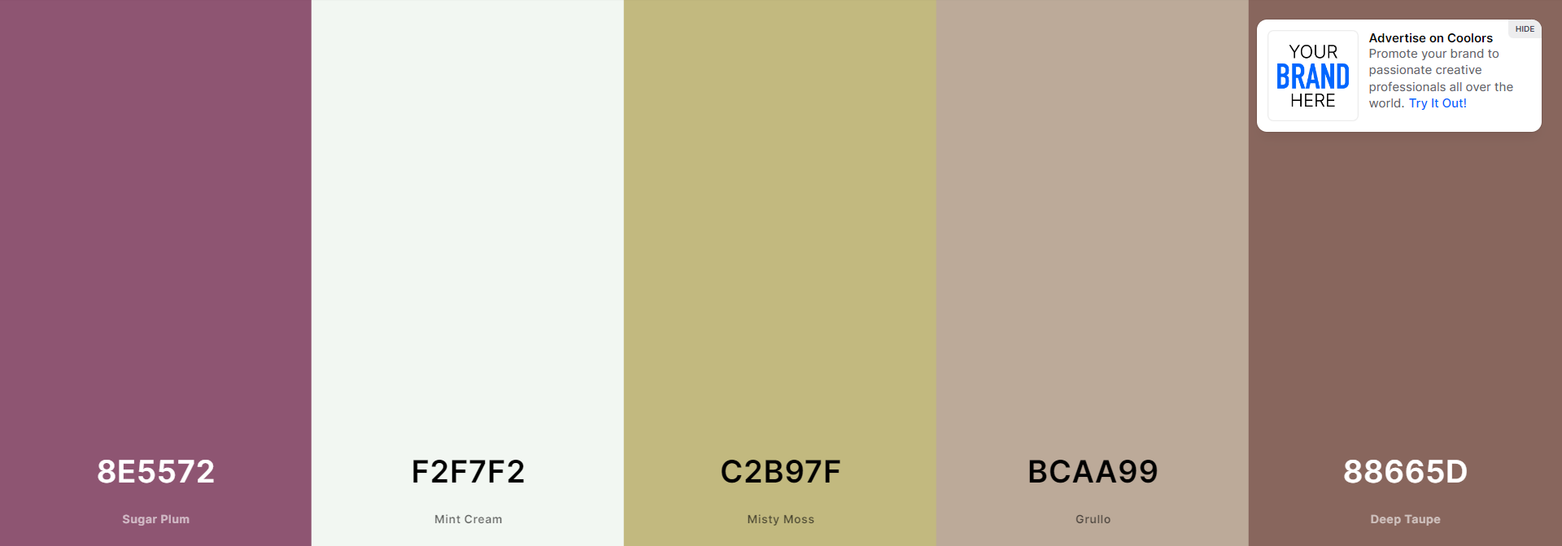

Typography:

Tittles and subtitles = Fanwood Text
This is an Example of a Title

Paragraph = IBM Plex Serif
This is how a paragraph written with the IBM Plex Serif Font would look like, this is how a paragraph written with the IBM Plex Serif Font would look like. This is how a paragraph written with the IBM Plex Serif Font would look. This is how a paragraph written with the IBM Plex Serif Font would look.
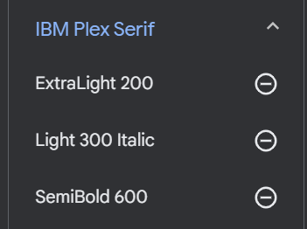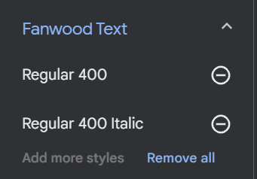
Link:
<style> @import url('https://fonts.googleapis.com/css2?family=Fanwood+Text:ital@0;1&family=IBM+Plex+Serif:ital,wght@0,200;0,600;1,300&display=swap'); </style>

- font-family: 'Fanwood Text', serif;
- font-family: 'IBM Plex Serif', serif;

Wireframe Sketches: Produce wireframe sketches of at least the home page of the site design considering the purpose, specifications, and target audience. You should include sketches for small, medium, and large views respectively meaning smart phones, tablets, and large width monitors.

